Sunday, April 2, 2023

2486 West 14th Street
Cleveland, Ohio 44113

(216) 781-5530
(216) 781-1124 Fax

Website: www.StAugustineCleveland. Org

Parish Office Hours:
Monday thru Friday: 9 AM to 4 PM
Saturday: 9 AM to 4 PM
Sunday: 9 AM to 2 PM

Community Cupboard and Closet:
Wednesdays: 5 PM to 7 PM
Saturdays: 11 AM to 2 PM

Mass Schedule:
Monday thru Friday: 5:30 PM
(Civic holidays at 10 AM)

Saturday: 4:15 PM*
Sunday: 8:30 AM* and 11 AM*
*Interpreted for the Deaf
Confession:

THE CATHOLIC COMMUNITY OF

ST. AUGUSTINE

A Samaritan Church with a Missionary Heart

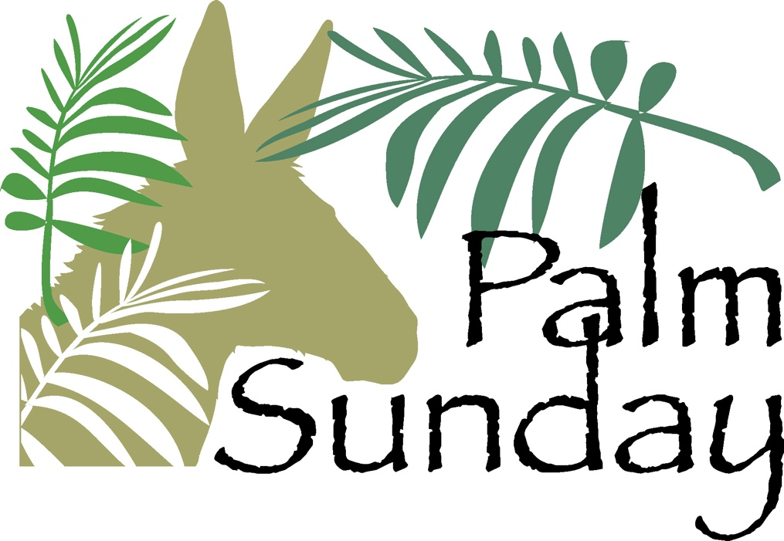

Parish Registration – Welcome new members! Please register by calling the parish office. Parishioners who are moving are asked to contact the office to update their information  Baptism – Baptisms may be scheduled at any time. Please call the parish office to make baptismal arrangements. | Funerals – Please call the parish office to schedule funerals prior to publishing any information.  Matrimony – Call the parish office to meet with a priest. Diocesan regulations require a minimum of 6 months preparation time. | Care of the Sick – Notify the parish office of those who are hospitalized or homebound. Arrangements can be made for pastoral visits, the Sacrament of the Anointing or the Sick. We can also bring Holy Communion to the homebound.
Saturdays 3:30 PM – 4 PM or by appointment
Staff and Ministry Directory
For all Parish emails, add @StAugustineCleveland.org
Administrator/Chaplain to the Blind: Rev. William O’Donnell, C.PP.S, email: WODonnell
Parochial Vicar/Chaplain to the Deaf: Rev. Ben Jimenez, SJ, email: BJimenez
Permanent Deacon: Chris DePenti, email: CDePenti@DioceseofClevleand.org Deaf Ministry: email: DeafMinistry
Parish Life Administrator: Bob Duda, email: BDuda Blind Ministry: email: BlindMinistry
Finance Manager: Aldo Fierro, email: AFierro Mental Health Ministry: MentalHealth
Office Manager: Doris Everetts, email: DEveretts Outreach Ministry: email: Outreach
Office Support: Kimberly Ambro, email: KAmbro Augustine Rainbow Camp: email: ARC
Director of Rainbow Camp and Volunteers: Jessica Neuhart, email: JNeuhart Signing Choir: email: SigningChoir Religious Education: Kathleen Ulintz, email: PSR General Information: email: Info
Deaf Access Co-Ordinator: Robin McMarlin, email: RMcMarlin

Palm Sunday
We greet the Lord today with palm branches and hosannas, welcoming him to the holy city of Jerusalem. His missionary journey and our Lenten journey are nearing their completion. Soon Jesus will celebrate the Passover with his closest disciples here in the center of the Jewish world. Before the sun rises, he will be betrayed by one of his friends, arrested, and taken away. He will be tortured, put on trial, and sentenced to death. He will die on the cross, be taken down, and be buried. From there he will be raised and will ascend to the holy city that is our eternal home. Today, as we shout our hosannas and wave our palm branches to welcome our Lord into Jerusalem, we look forward to the day when we will all be welcomed into the new Jerusalem.
Mass Intentions for the Week

Saturday, April 1st- 4:15 PM † Liz Kinney
Fr. Bill O’Donnell, C.PP.S
Sunday, April 2nd- 8:30 AM † Gerry Bastaich
Fr. Ben Jimenez, SJ
Sunday, April 2nd– 11 AM † John & Mary Schepis
Fr. Bill O’Donnell, C.PP.S
Monday, April 3rd- 5:30 PM † Herbert Sponholtz
Tuesday, April 4th- 5:30 PM † Coletta Klein
Wednesday, April 5th- 5:30 PM † Terry Klima
Thursday, April 6th- 6:30 PM † Mary Ashdown
Friday, April 7th- 7 PM The Lost and Forgotten
Saturday, April 8th- 8:45 PM St. Augustine Community
Fr. Ben Jimenz, SJ Living and deceased
Sunday, April April 9th- 8:30 AM St. Augustine Community
Fr. Bill O’Donnell, C.PP.S Living and deceased
Sunday, April 9th– 11 AM St. Augustine Community
Fr. Joe McNulty Living and deceased

Welcome!
No matter what your present status in the Catholic Church, no matter your personal history, age, income, background, gender, disability, sexual orientation, race, ethnicity or spirituality, or marital situation. No matter your own self-image of holiness or virtue. You are invited, accepted, and respected here at St. Augustine Parish.

Loving God,
For all who feel on the margins,
but who are at the center of your heart,
we ask you to open our hearts.
Help us to become a church and a nation where:
All lives have dignity,
All people are loved
And all are welcome.
Amen

READINGS FOR THE WEEK
Sunday: Mt 21:1‐11 (procession); Is 50:4‐7; Ps 22:8‐9, 17‐18, 19‐20, 23‐24; Phil 2:6‐11; Mt 26:14 — 27:66 or Mt 27:11‐54
Monday: Is 42:1‐7; Ps 27:1‐2, 3, 13‐14; Jn 12:1‐11
Tuesday: Is 49:1‐6; Ps 71:1‐2, 3‐4a, 5ab‐6ab, 15, 17; Jn 13:21‐33, 36‐38
Wednesday: Is 50:4‐9a; Ps 69:8‐10, 21‐22, 31, 33‐34; Mt 26:14‐25
Thursday: Chrism Mass: Is 61:1‐3ab, 6a, 8b‐9; Ps 89:21‐22, 25, 27; Rv 1:5‐8; Lk 4:16‐21 Lord’s Supper: Ex 12:1‐8, 11‐14; Ps 116:12‐13, 15 ‐16bc, 17‐18; 1 Cor 11:23‐26; Jn 13:1‐15
Friday: Is 52:13 — 53:12; Ps 31:2, 6, 12‐13, 15‐ 16, 17, 25; Heb 4:14‐16; 5:7‐9; Jn 18:1 — 19:42
Saturday: a) Gn 1:1 — 2:2 or Gn 1:1, 26‐31a; Ps 104:1‐2, 5‐6, 10, 12, 13‐14, 24, 35; or Ps 33:4‐5, 6‐7, 12‐13, 20, 22; b) Gn 22:1‐18 or Gn 1‐2, 9a, 10‐13, 15‐18; Ps 16: 5, 8, 9‐10, 11; c) Ex 14:15 — 15:1; Ex 15:1‐2, 3‐4, 5‐6, 17‐18; d) Is 54:5‐14; Ps 30:2, 4, 5‐6, 11‐12, 13; e) Is 55:1‐11; Is 12:2‐3, 4, 5‐6; f) Bar 3:9‐15, 32 — 4:4; Ps 19:8, 9, 10, 11; g) Ez 36:16‐17a, 18‐28; Ps 42:3, 5; 43:3‐4 or Is 12:2‐3, 4bcd, 5‐6 or Ps 51:12‐13, 14‐15, 18‐19; h) Rom 6:3‐11; i) Mt 28:1‐10
Sunday: Acts 10:34a, 37‐43; Ps 118:1‐2, 16‐17, 22‐23; Col 3:1‐4 or 1 Cor 5:6b‐8; Jn 20:1‐9

The Pope’s Intention for April:
For a culture of peace and non-violence
We pray for the spread of peace and non-violence, by decreasing the use of weapons by States and citizens.

Love Without Measure

Palm Sunday begins the solemn journey for Christians that we call Holy Week, the holiest week in the Church year. It is not simply about palms although palms are an important symbol for the week that lies ahead as we follow Jesus to the table of service we call Holy Thursday, Mass of the Lord’s Supper, Good Friday as we remember Christ’s Death on the Cross and the suffering of humanity that the cross will embody until the end of time. Finally, we are a people of new life and hope as Easter testifies and give witness to Christ’s victory over sin and death. A victory we shall in now in an incomplete manner but in its fullness on the last day.

For many palms are an important symbol that active and inactive Christians will come to church to acquire, put in some place of honor in their homes for the coming year and for some to be braided into a cross. These same palms will be burned to provide the ashes that will sign us as we begin the season of Lent on next Ash Wednesday. It is always amazing to me how everything is tied together on this journey we call the paschal mystery.

Practically Palm Sunday gats my attention because of the crowds that follow Jesus into Jerusalem waving the palms and crying out “Hosanna in the Highest!” These would be the same crowds that would cry out “Crucify Him!” on Good Friday. More than would admit in life follow the crowd with no more commitment than what the moment demand. An important Palm Sunday question for us is “Who are you following and why?”

In a time when the truth is what is convenient and serves my needs creates a world of confusion, lack of trust, where the truth is what I choose it to be. No wonder the times are so difficult for so many and trust is a commodity almost non-existent. No wonder so many feel lost and follow the first person who comes along promising something that seems so good but has no foundation.

On Palm Sunday as we carry our palms from church let us consider as we journey through Holy Week and beyond what it means to follow the Risen Christ and the great hope that faith inspires.

Holy week invites the renewal of our faith but has its focus not what we do but what Christ has done for all humanity and for all time. Christ had died, Christ has risen, Christ will come again.
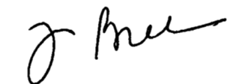

.

Eternal Rest Grant Unto Them, O Lord

Gladys Torres
Longtime member of our Parish

John Horan
Member of the Deaf Community

Parish Fish Fry
Our last Fish Fry will be held this Friday from 4 PM to 6:30 PM in Walsh Hall (basement of former school building) We will have battered fried cod, salmon, shrimp, pierogis, cheese pizza, hush puppies, French fries, macaroni and cheese, coleslaw, and apple sauce. A complete menu can be found on our website.

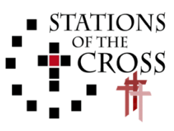
Join us on Good Friday as we meditate on the Stations of the Cross at 2 PM. The Stations are a devotion intended to help us follow Jesus on his way to Calvary. Anyone wishing to lead a Station is asked to contact the Parish Office at (216) 781-5530.
Matthew 25 Pilgrimage
Join us as we travel together by bus on Good Friday (April 7) to reflect and pray at six different sculptures repreesnting the areas called out in the Gospel of Matthew to care for the leaset of our brothers and siters in need. The bus will leave the parish at 9:30 AM and return by Noon. Please call the Parish Office at (216) 781-5530 to sign up.
24th Interfaith Seder Meal
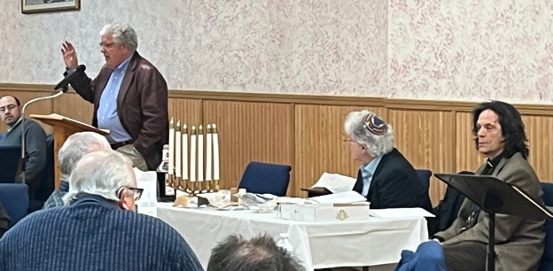
We were once again blessed to have members of the Jewish community join us for our annual Interfaith Seder Meal. Herb Ascherman, Jr., and cantor emeritus Gary Paller guided us through the Seder with historical context and song.

Haunted by God
The Life of Dorothy Day

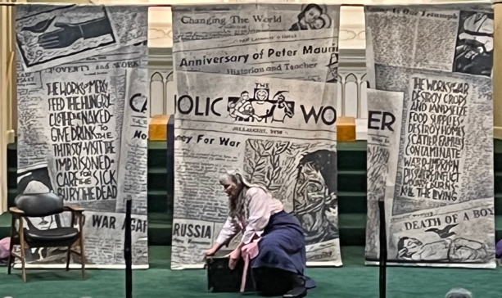
Thank you to all who came to the one woman play portraying the life of Dorothy Day this past Thursday. For more information on Dorothy Day and the Catholic Worker Movement, please visit: www.catholicworker.org.

Church Stations of the Cross
Our Stations of the Cross have returned. We hope that you will be pleased with the restoration. Thank you for your patience and understanding while they were removed and being restored.

Mary’s Rosary Guild of the Deaf
60th Anniversary
Mary’s Rosary Guild of the Deaf will celebrate their 60th Anniversary on Sunday, April 30, 2023 from 12 Noon until 5 PM in Walsh Hall. Tickets are $25 and can be purchased by contacting the parish office at (216) 781-5530 or by mailing a check or money order payable to Mary’s Rosary Guild of the Deaf to MRGD at 2486 W. 14th Street, Cleveland, Ohio 44113.

St. Augustine Seniors
50 and over
The St. Augustine Seniors will celebrate Easter at their meeting on Thursday, April 13th at 12 Noon in Walsh Hall. New members are always welcome.

St. Augustine Buckeye Deaf Seniors
St. Augustine Buckeye Deaf Seniors will gather in the Deaf Center on Tuesday, April 11th at 10 AM for their regular meeting. New members are always welcome.
St. Augustine Signing Choir
The St. Augustine Signing Choir will not have practice this week. Anyone interested in joining the choir, with or without signing experience, is invited to join. For more information, please contact the parish office
Parish School of Religion
Due to Holy Week and Easter, PSR will not meet on Monday, April 3rd or Monday April 10th. Classes will resume on Monday, April 17th at 5:30 PM.

For more information, please visit St. Augustine Parish website at www.StAugustineCleveland.org, email us at PSR@staugustinecleveland.org, or call the parish office at (216) 781-5530 for more information.
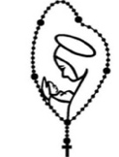
Pr ay the Rosary
We invite you to join us every Monday through Friday at 6 PM in Church as we pray the rosary. Due to the Mas schedule during Holy Week, we will not pray the rosary together as a parish family on Wednesday, Thursday, or Friday. If you are unable to join us in person, we encourage you to join us on livestream.

We live stream the Saturday 4:15 PM Mass, the 11 AM Mass on Sunday, and the weekday Rosary on the parish website, Facebook Page, and YouTube Channel. A live audio feed will be available for the Saturday 4:15 PM Mass the 11 AM Sunday Mass, and the praying of the Rosary. To access the audio feed, please call (216) 270-6331prior to mass and enter code 2020 when prompted
Political Messiah and Palm Sunday Connection!
A key element of understanding the connection between the Palm Sunday receptions given to Jesus and Good Friday is to recognize that the actions, words and symbols of Palm Sunday indicated a religious and political Messiah who would save the Jews from foreign rule and regain for them religious and political freedom. The occasion of reception was carefully chosen by Jesus’ disciples to coincide with the Passover feast which celebrated the Jewish liberation from Egyptian rule and slavery. The palms used in the procession and the slogan used (Hosanna meaning save us, God) were those used in the 164 BC Maccabean victory parade to the Temple. That parade took place after the Maccabean army, led by Judas Maccabeus, had defeated the ruling Greek king and his army and liberated both the city of Jerusalem and the Temple which the Greeks had desecrated. In 1 Maccabees 13:51, we read: “On the twenty‐ third day of the second month, in the one hundred seventy‐ first year, the Jews entered it with praise and palm branches, and with harps and cymbals and stringed instruments, and with hymns and songs, because a great enemy had been crushed and removed from Israel.” It was natural, then, that the Romans saw the crowds of people carrying palm branches and giving a royal reception to a very popular, miracle‐working rabbi, Jesus, as a potential threat to their power and a banner for revolution. Hence, the governor Pilate and his counselors were justified in their concern. They interpreted people’s slogan “Hosanna” as “save us” from Roman occupation. Besides, the Jewish rabbi had been teaching that the final redemption of the Jews would take place with the Messiah’s arrival. With 1½ to 2 million Jews in and around the city for the Passover, the situation was highly volatile, and Jesus’ ride on a donkey as prophesied by Zachariah seemed to have all the signs of producing great trouble and revolt. So the Romans informally made allies of some of the Temple priesthood (largely Sadducees) who were planning to arrest Jesus (the suspected center for the trouble), because these priests were the people most closely allied to Rome, and would lose their power and income in the case of a popular uprising. This collusion between Pilate and the High Priest Caiaphas and their supporters is exactly what we see in the Passion accounts describing the arrest, trial and crucifixion of Jesus. Given the political, religious and social context, this is hardly surprising. Keeping that in the back of our minds helps us to make sense of certain parts of the action that will follow.

Parish Database Update
If you have moved, are now solely using a cell phone, or have please call the parish office, so we can update your records. We would also like to update our parish data base with e‐mail addresses. Thank you for keeping our parishioner records current.

Protecting God’s Children
The Diocese of Cleveland’s “Protecting God’s Children” program is a continuing effort to instruct and inform everyone about the protection of children from sexual abuse. To report any past or present suspected inappropriate behavior toward children by priests, deacons, religious, lay ecclesial ministers or personnel associated with the Church, please contact the Diocesan Response Service Office at (216) 334 -2999 or via email at response_services@dioceseofcleveland.org. You are also asked to immediately inform local authorities about inappropriate behavior.
Sunday Thought
With the coming of Palm Sunday, there is a notable change in our Lenten observance. From this day forward, we look toward celebrating the central mysteries of our Faith found in Jesus’ Death, and Resurrection. It is true that Jesus did not seek the cross. It is just as true to say also that Jesus did not refuse the cross either. Jesus took up the cross knowing that He carried it for each of us. It is also central to our faith to say that Jesus shared in our human nature by His birth. It is even more essential to our faith to say that He became even more human by sharing in our sufferings. We therefore have a Savior who understands us not only in the body, but also one who understands us with His very heart. Our crosses are also His crosses. The pain we suffer is the pain He also suffers. No longer are we alone. Jesus is with us in every aspect of our life. As we move through Holy Week may we come to know that our Savior walks with us carrying our crosses along with His own.
Due to Easter, Ultreya will not meet in April. Cursillistas will gather for Ultreya on Saturday, May 13th at 10 AM in Walsh Hall. Cursillistas are invited to gather, pray, and share personal stories about living a life in God's Grace on the second Saturday of every month.

Stewardship of Treasure
We are deeply grateful for your generosity in your weekly contribution to St. Augustine Parish. Your kindness and support enable us to provide for the needs of our parish and community. The collection for the weekend of March 26, 2023 was $1,709.00. Thank you for your generosity.
Counter Team A is scheduled for Monday.

Donkey with a Christian name?
An interesting as well as challenging old fable tells of the colt that carried Jesus on Palm Sunday. The colt thought that the reception was organized to honor him. “I am a unique donkey,” this excited animal might have thought. When he asked his mother if he could walk down the same street alone the next day and be honored again, his mother said, “No, you are nothing without Him who was riding you”. Five days later, the colt saw a huge crowd of people in the street. It was Good Friday, and the soldiers were taking Jesus to Calvary. The colt could not resist the prospect of another royal reception. Ignoring the warning of his mother, he ran to the street, but he had to flee for his life as soldiers chased him and people stoned him. Thus, the colt finally learned the lesson that he was only a poor donkey without Jesus riding on him. As we enter Holy Week, today’s readings challenge us to examine our lives to see whether we carry Jesus within us and bear witness to him through our living or we are Christians in name only.

Family Perspectives
The cruel death of Jesus tells us bad things can and do happen to very good people. It also tells us God is present during the suffering. Bad things happen but God does not abandon us.

The St. Augustine Community Cupboard is open on Saturdays from 11 AM - 2 PM and Wednesdays from 5 PM - 7 PM.
As we continue to serve the needs of our neighbors, we are seeking volunteers to assist in restocking shelves and assisting shoppers on the days we are open. In addition, we are in need of the following items:

Toilet Paper Canned Meat
Paper Towels Ketchup
Laundry Detergent Mustard
Dish Soap Mayo
Coffee Dog Food
Tea Deodorant (Men and Women)
Sugar Hand Soap (Pump Bottles)
Creamer Body Wash (Men and Women)
Flour Shampoo
Kleenex Boxed Potatoes
We have also created an Amazon Wish List which can be found on our parish website, www.StAugustineCleveland.org.

For more information or to volunteer, please contact the parish office by calling (216) 781-5530.
Community Closet
Our Community Closet allows individuals to come and “shop” for clothing, bedding, and footwear items.

We are in need of shoes, t-shirts and underwear and socks.

The Community Closet is open on Wednesdays from 5 to 7 PM and on Saturdays from 11 AM to 2 PM.

For more information or to volunteer please contact the Parish Office at (216) 781-5530 or email, outreach@staugustinecleveland.org.

Community Closet and Cupboard
Highlights by the Numbers
♦ Served over 777 families in the month of March
♦ 127 new families came to shop during the month of March

Tenebrae Service
An interpreted Tenebrae Service of Shadows and Light will be held Monday, April 3 at 7pm at St. Malachi Church (W. 25th and Detroit Ave). Tenebrae is a Holy Week devotion which dates back to the 7th or 8th century and is characterized by scripture, hymns and the successive extinguishing of candles as the service progresses. This beautiful prayer has become a longstanding collaboration of the Catholic churches of our Central West District.
Easter Flowers
If you would like to donate toward Easter flowers to decorate the church this Easter season, please place an envelope clearly marked “Easter Flowers” in the collection basket before April 3rd. Envelopes may also be dropped off at the Parish Office. If you would like your donation to be in memory of someone and would like their name(s) recognized in the bulletin, please mark “in memory of (loved one’s name) on the envelope as well.

Chrism Mass at the Cathedral of St. John the Evangelist
At 7 PM on Tuesday, April 4, 2023, Bishop Edward Malesic will celebrate the Chrism Mass with the priests of the Diocese. At the Mass, all priests make a Renewal of Commitment to Priestly Service, recommitting themselves to their Bishop and to their ministry to God and His People; the Bishop and all Priests then ask the people for a pledge of their prayerful support.

The Bishop will also bless and consecrate the Holy Oils, which each parish receives for the rites of anointing. The Oil of Catechumens is used to anoint infants and adults before their Baptism; the Oil of the Sick is used on the forehead and hands of the infirm in the Sacrament of the Anointing of the Sick; and Sacred Chrism is used to anoint the head of the newly baptized, the foreheads of Confirmandi, the hands of a priest at his ordination, the head of a bishop at his ordination, and the altar and walls of new churches.

St. Augustine Church will provide sign language interpreters and audio-description. We will have reserved seating in the Sacred Heart Transept of the Cathedral.

Alhambra
A number of St. Augustine Parishioners are members of the Catholic organization Carmona Caravan, a group of Catholic men and women dedicated to assisting persons with intellectual
Disabilities.

Carmona Caravan is the Cleveland based chapter of the Order of the Alhambra. They meet on the 2nd Tuesday of each month, and all are welcome! If you are interested in helping persons with intellectual disabilities, coming to a meeting, or learning more, please visit www.carmonacaravan.org.
“But you wear a Cross!”
On her first night there, the head counselor said that three of the boys had asked to escort her to dinner. Alone! How would she handle it if all three decided to act out at once? She swal‐ lowed hard. She desperately needed this job so she fought back the panic and walked with her charges to the dining hall. They passed through the cafeteria line as tantrums and fights erupted around them. Fortunately none of her boys exhibited any kind of behavioral outburst. They made their way to a ta‐ ble in the center of the busy cafeteria and the boys took their seats. Margaret picked up her fork and was about to take the first bite when she noticed that all three boys were staring at her. "What's the matter?" she asked. Aren't you going to ask a blessing?" asked eight‐year‐old Peter. "I didn't think I was sup‐ posed to," she responded. "This is a state school, isn't it?" "Yes," said David, his blue eyes brimming, "but you wear a cross." Her grandmother's words surged to the surface of her memory. "Never forget what this cross means," her grand‐ mother said. "We thought that meant something," said Ro‐ man, clearly disappointed. "It does. Thank you for reminding me," Margaret said, as she bowed her head, no longer afraid.
Church Decorators Needed
We are looking for volunteers to help decorate the church for Holy Thursday and Holy Saturday. Please contact Bob Duda in the Parish Office at (216) 781-5530 or bduda@staugustinecleveland.com for more information.
Arrested and handcuffed on a Palm Sunday!
The light turns green, but the man doesn’t notice that the light has changed. The woman behind him begins pounding on her steering wheel and yelling at the man to move! The man doesn’t move! The woman is going ballistic, ranting and raving at the man, pounding on her steering wheel. When the light turns yellow, the woman begins blowing her car’s horn and screaming curses at the man. Finally, the man looks up, sees the yellow light, and accelerates through the intersection just as the light turns red.

While she is still ranting, she hears a tap on her window and looks up into the barrel of a gun held by a very serious looking policeman. The policeman tells her to pull her car to the side, shut off the engine, come out and stand facing the car, while keeping both hands on the car roof. She is quickly cuffed, and hustled into the patrol car. The woman is too bewildered to ask any questions, and she is driven to the police station, where she is fingerprinted, photographed, searched, booked, and locked up in a cell. After a couple of hours a policeman approaches the cell, and opens the door. The policeman hands her the bag containing her things, and says, “I’m sorry for this mistake, but you see, I pulled up behind your car while you were blowing your horn, and cursing at the car in front of you. I noticed the Choose Christ license plate holder, and the “Follow Me to Sunday School” bumper sticker, and Palm Sunday palm leaves inside the back windshield. So naturally I assumed you had stolen the car because such a nice Christian, who courageously displays Christian symbols in her car, would never act as you did.”

Anointing of the Sick and Communal Penance
We will celebrate a Lenten Anointing of the Sick and Communal Penance Service on Wednesday of Holy Week, April 5th at 6 PM. The Service consists of song, scripture, a homily, an examination of conscience and time for private Confession of sin. Come and spend some quality time with the Lord of Healing and Forgiveness.

The Stole and the Towel
The Stole and the Towel That is the title of a book, which sums up the message of the Italian bishop, Tony Bello, who died of cancer at the age of 58. On Maundy Thursday of 1993, while on his deathbed, he dictated a pastoral letter to the priests of his diocese. He called upon them to be bound by “the stole and the towel”.

The stole symbolizes union with Christ in the Eucharist, and the towel symbolizes union with humanity by ser‐ vice. The priest is called upon to be united with the Lord in the Eucharist and with the people as their serv‐ ant. Today we celebrate the institution of both the Eucharist and the priesthood: the feast of “the stole and the towel” the feast of love and service.

On the Lighter Side
Little Johnny was sick on Palm Sunday and stayed home from Church with his mother. His father returned from church holding a palm branch. The little boy was curious and asked why. His father explained, “You see, when Jesus came into town, everyone waved palm branches to honor him; so we got palm branches today. “Aw, shucks,” grumbled Little Johnny.; “The one Sunday I can’t go to Church, and Jesus shows up!”☺

Benedict the Black
Feast Day: April 4

Benedict was a slave, but he always knew that his only true master was Jesus. Benedict’s parents, Christopher and Diana Manasseri, were taken from their home in Africa and sold into slavery in Messina, Italy, where Benedict was born in 1524.
Given his freedom when he was 18, Benedict worked as a farmer until he had saved enough to buy a pair of oxen. They were the first things he had ever owned. In time, Benedict joined a group of hermits, prayerful men who lived quiet lives devoted to God. They followed the teachings of St. Francis and were called friars. Benedict worked in the friary kitchen.
Benedict was chosen to train the young men who joined the order. Then he was chosen to be the guardian, or superior, of the friars. He had never wanted to be a leader, but he responded to his new role by being a cheerful and humble leader who inspired others to grow in their love for Jesus and service to others. He could not read or write. When his term ended, Benedict happily returned to his work in the kitchen.
People in Sicily came to the friary to seek Benedict’s advice and to ask for his prayers. He became so beloved that when he died in 1589, the King of Spain paid for a special tomb to be built for him.
St. Benedict the Black is also sometimes called “Benedict the Moor” (yet he is unlikely to have any Moorish heritage). He is the patron saint of African missions and of persons of African descent. He was canonized in 1807 by Pope Pius VII
April 1st and 2nd
 | Saturday  4:15 PM | Sunday  8:30 AM | Sunday  11 AM
Priest  Deacon | Fr. Bill O’Donnell, C.PP.S  Deacon Chris DePenti | Fr. Ben Jimenez, (H) | Fr. Bill O’Donnell, C.PP.S (H)  Deacon Chris DePenti
Lectors | Robin McMarlin | Joe Lewandowski | Tom Smith  Aaron Calton
Extraordinary Ministers of the Blessed Sacrament | Theresa Ortiz  Michelle Rivera | Bob Duda  Robin McMarlin  Maria Rivera | Rosanne Barnhart  Tom Calton
April 8th and 9th
 | Saturday  8:45 PM | Sunday  8:30 AM | Sunday  11 AM
Priest  Deacon | Fr. Ben Jimenez, SJ  Deacon Chris DePenti | Fr. Bill O’Donnell, C.PP.S (H)  Deacon Chris DePenti | Fr. Joe McNulty (H)  Deacon Chris DePenti
Lectors | Dave Dylyn | Fran DiDonato | Tom Smith  Sr. Regina Fierman, CSA

H: Homilist
Extraordinary Ministers of the Blessed Sacrament | Helen Bencic  Kate Slosar | Marissa Davilla  Pat Abraham | Bob Cassidy  Molly Cassidy  Bob Duda
This Week’s Events of the Parish
Monday: Mass: 5:30 PM (Church)
Rosary: 6 PM (Church)
Tenebrae: 7 PM (St. Malachi Church)
AA Meeting: 7:30 PM (Mylott Hall)
Tuesday: AA Meeting: 9:30 AM (Walsh Hall)
Mass: 5:30 PM (Church)
Rosary: 6 PM (Church)
Chrism Mass: 7 PM (Cathedral)
AA Meeting: 7:30 PM (Mylott Hall)
Wednesday: Community Cupboard and Closet: 5 PM-7PM
Mass: 5:30 PM (Church)
Communal Penance & Anointing of the Sick: 6 PM
AA Meeting: 6 PM (Mylott Hall)
Thursday: Mass of Lord’s Supper: 6:30 PM (Church)
Parish Fellowship Meal: 7:30 PM (Walsh Hall)
Reposition of the Blessed Sacrament: until 11 PM
AA Meeting: 7 PM (Mylott Hall)
Friday: Matthew 25 Pilgrimage: 9:30 AM (Meet at Church)
Stations of the Cross: 2 PM (Church)
Parish Fish Fry: 4PM – 6:30 PM (Walsh)
Liturgy of Lord’s Passion: 7 PM (Church)

Saturday: Community Cupboard and Closet: 11 AM – 2 PM Blessing of Easter Food: 2 PM (Church)
Mass: 8:45 PM (Church)
Sunday: Mass: 8:30 AM (Church)
Mass: 11 AM (Church)

